Edward Olive – fine art photographer & international destination wedding photographer
Email: edwardolive@hotmail.com
Web: http://www.edwardolive.info/

Tel: 0034 605610767

Photography services for weddings & social events.
Portraits, books for actors, child & pregnancy photos.
Commercial photography for companies, CD & book covers, corporate brochures & advertising.

Premios Gràffica 2010
“The work of Edward is an important evolution in social reportage photography. To see weddings from a cinematic point of view, to try to transmit the different atmospheres and their attributes, as well as the characters of those attending is a declaration of intentions.
To see where no-one sees, to observe what the rest of us don’t see or to see it in a different way.”
Edward Olive

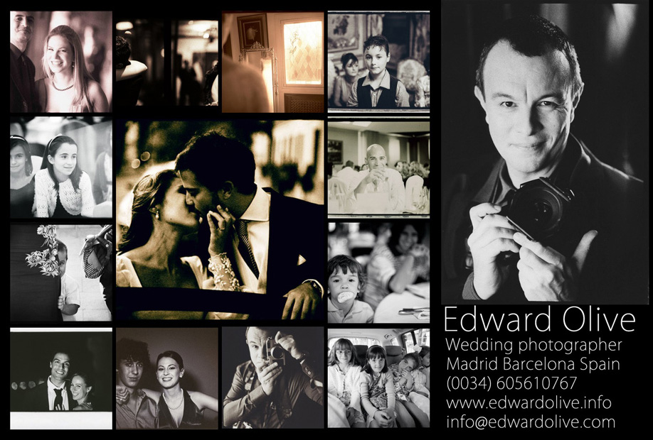

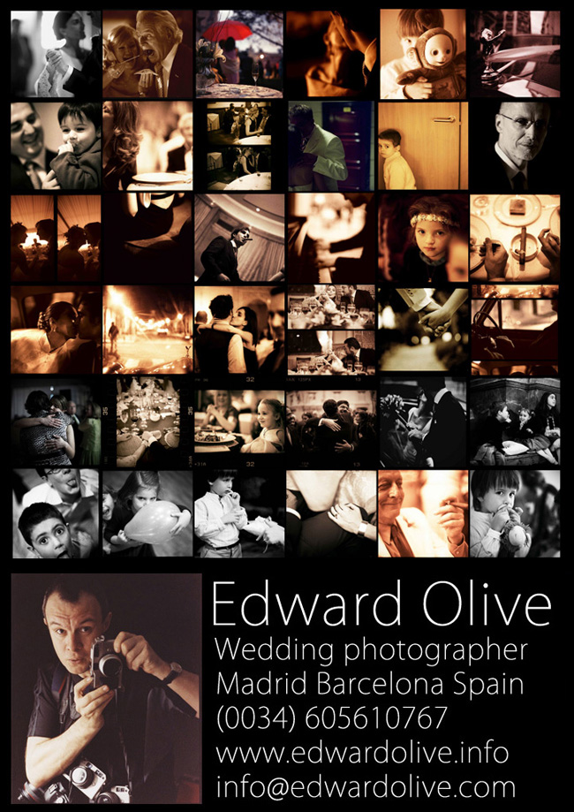

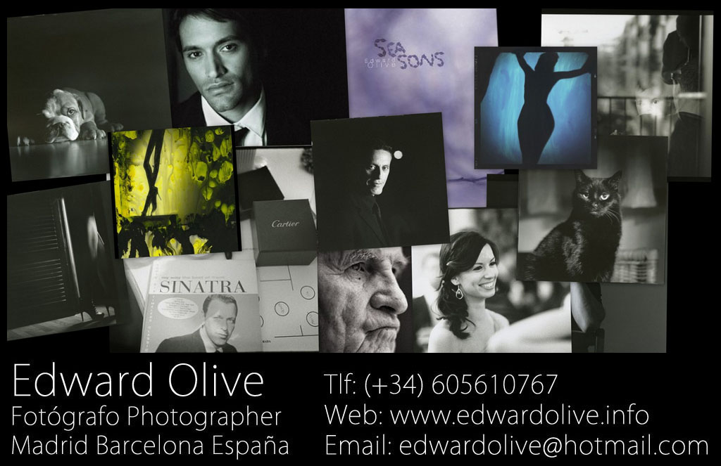
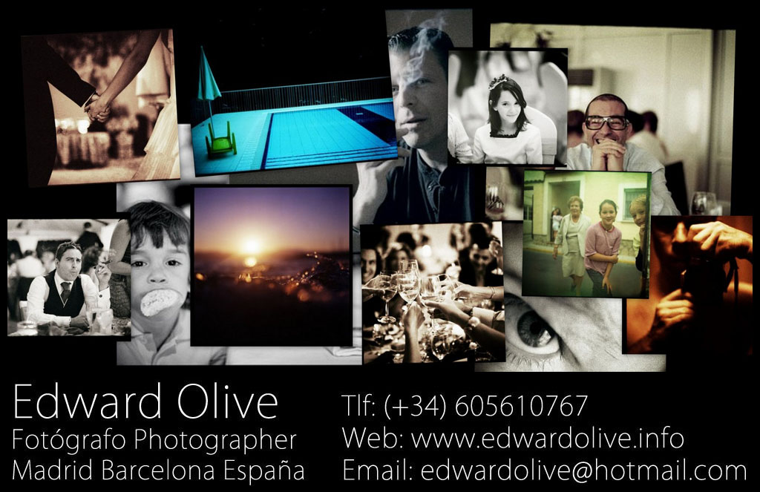
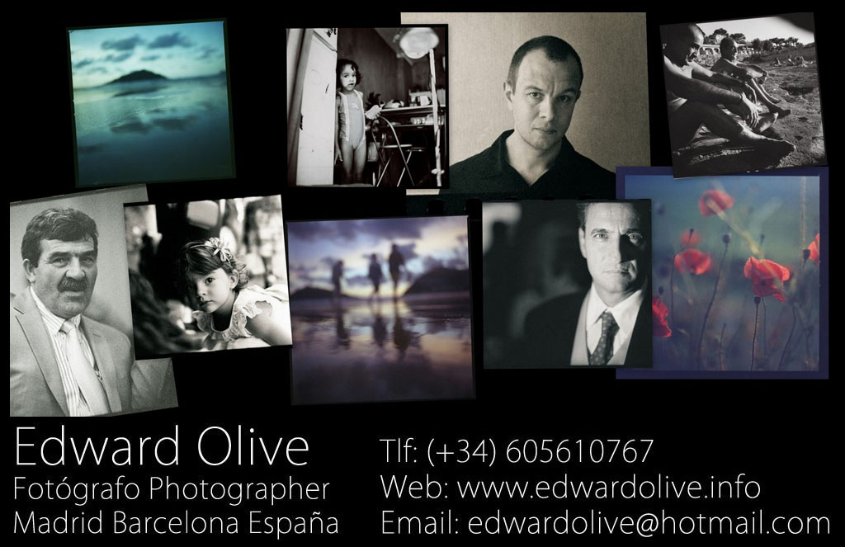
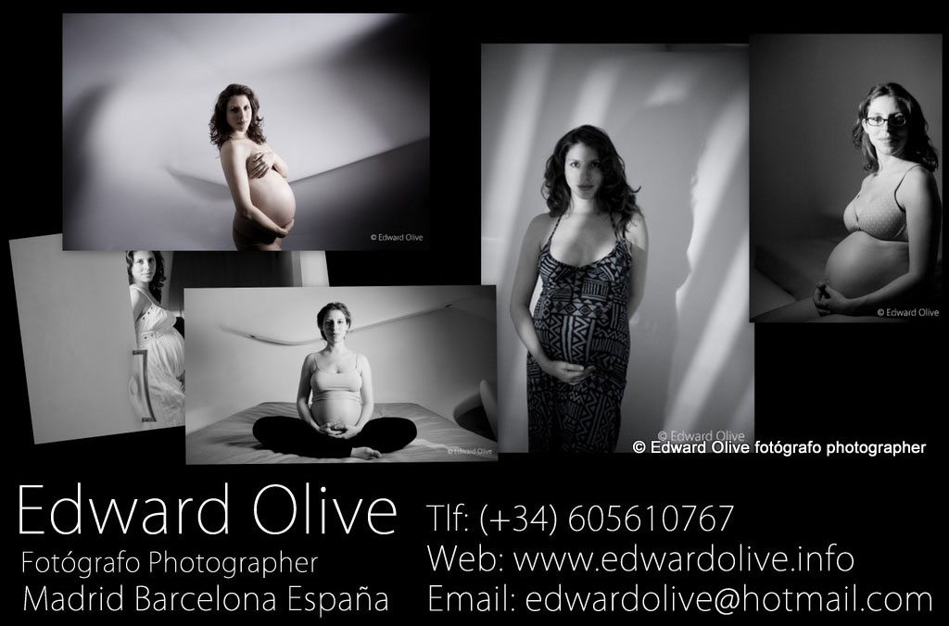
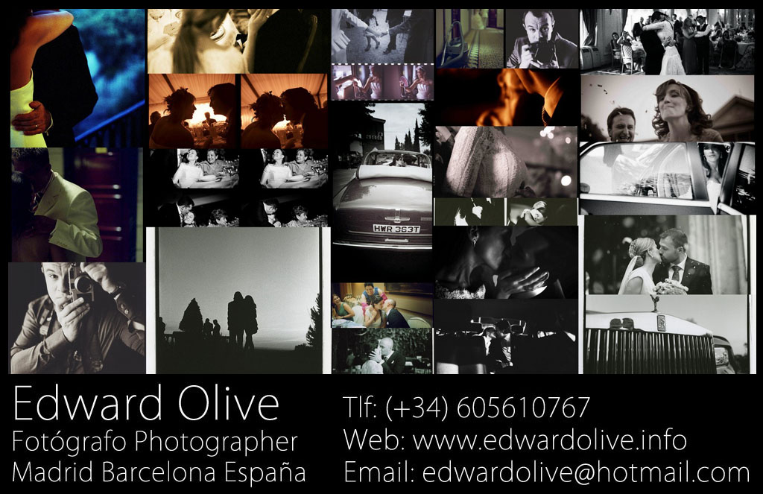
Photography awards

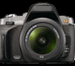

2012 Ganador del concurso de fotografía de bodegones The New Camera Still Life Photo Contest

2012 Ganador del concurso de fotografía de retratos The New Camera People & Portrait Photo Contest
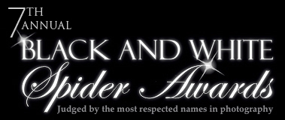

2012 7th Annual Black & White Spider Awards – nominee in the category professional nude
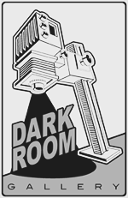
2012 The Darkroom Gallery - The Human form – Honorable mention
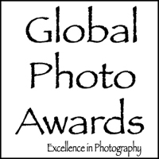
2011 Global Photo Awards
Advertising Photography 2nd Place - Merit of Excellence
Advertising Photography 3rd Place - Honor of Distinction
Fashion Photography 2011 Judges Choice - Honorable Mention
Still Life Photography 2011 Judges Choice - Honorable Mention

2011 The New Camera Red Photo Contest Featured Image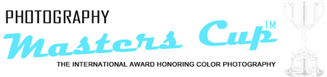

2011 5th Annual Photography Masters Cup Nominee in the Professional category: Nude

2011 TeraBella Media photography contest “What Happens at Night” Merit Winner
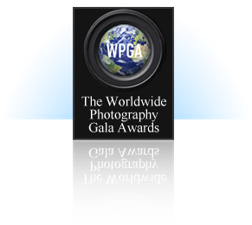
2011 First Prize in Wedding Photography and Second Prize in Portrait Photography in The Worldwide Photography Gala Awards WPGA August Contest/Pollux Awards
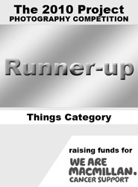

2011 The 2010 Project Photography Competition Runner up in the Still Life Things category and finalist in the Portraiture category

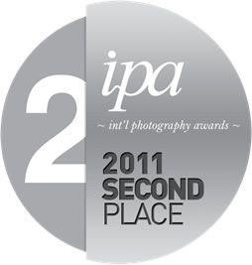

2011 International Photography Awards 2nd place in Fine Art - Nudes for the winning entry "Private Collection"

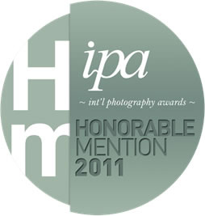
2011 International Photography Awards Honorable Mention in People : Wedding category for the winning entry “Young lady at wedding"
2011 International Photography Awards Honorable Mention in the Pets category for the winning entry “Le chat film noir"
2011 The Worldwide Photography Gala Awards May Contest Pollux Awards Portfolio Section - Professional Photographers Figure and Nude: 1st Prize
2011 The Worldwide Photography Gala Awards 2nd Edition of the Black & White Competition Second Prize & Special Mention of the Jury in the category Nude & Figure.

2011 Chasing The Light Juried Photography Pet photography Who’s your best friend? Competition Runner Up

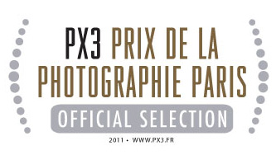

2011 Nominated Prix de Paris Px3 Official Selection in the categories Portraiture/Wedding, Portraiture/Personality, Portraiture/Children, Press/People/Personality, Fine Art/Nudes, Nature, Advertising/Book Cover, Advertising/Annual Reports

2011 Prix de Paris Px3 People's Choice First Prize in the category Advertising/Annual Reports
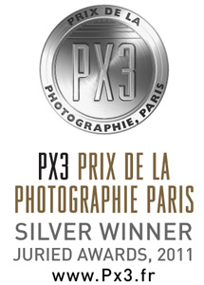

2011 Prix de Paris Px3 Silver award in the category Advertising

2011 Prix de Paris Px3 Silver award in the category Nature

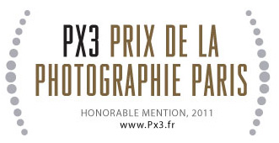

2011 Prix de Paris Px3 Honourable mention in the category Fine art nude

"PX3 is Europe's biggest and most prestigious photography competition" CamerArts Magazine

2011 2nd Prize and 3rd Prize in The Worldwide Photography Gala Awards April Pollux Awards Contest in the category Figure and Nude

2011 Honorable Mention in The Worldwide Photography Gala Awards Best Shot Competition



2011 3rd place winner in the ephotoawards.com art photography competition “Color Awards 2011”
2011 Special Mention of the Juror in The Worldwide Photography Gala Awards (WPGA) The Beauty Around Us Contest

2011 Gold Award In the The Worldwide Photography Gala Awards (WPGA) Portrait & People 2011

2011 Runner Up in the Chasing the light - Landscapes – Beyond The Mundane Photo Competition with his picture "Summer evening 1"

2011 Featured image of thenewcamera.com photo contest “Your best shot”



2010 winner of the telegraph.co.uk The Daily Telegraph Photo competition: Forgotten

2010 Third place finalist in the photography competition V Concurso fotográfico FOTO DNG 2010 magazine with the picture “Young lady goes through door”.

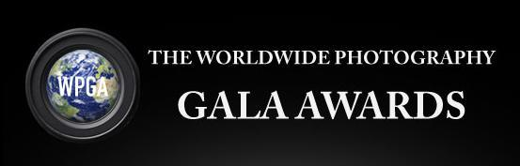

2010 - First prize in the WPGA 2010 World Photography Gala Awards / The Pollux Awards - professional wedding category

2010 - Finalist in the WPGA 2010 World Photography Gala Awards / The Pollux Awards in the Professional Photographers categories: Children, Figure & nude, Macro & Micro, Still Life, Wedding,
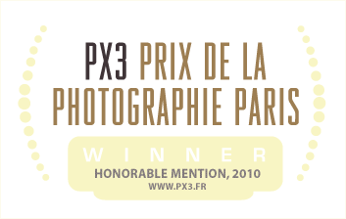

2010 - HONORABLE MENTION WINNER OF PX3, Prix de la Photographie Paris in the category Fine Art/Nudes for the entry entitled, " ^ "
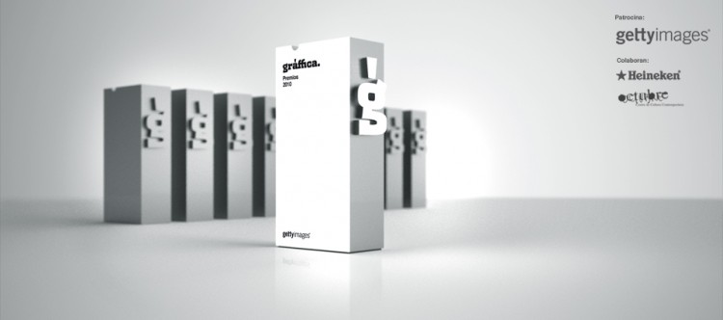

2010 nominated for the Premios Gràffica 2010
“The work of Edward is an important evolution in social reportage photography. To see weddings from a cinematic point of view, to try to transmit the different atmospheres and their attributes, as well as the characters of those attending is a declaration of intentions.
To see where no-one sees, to observe what the rest of us don’t see or to see it in a different way.”

2010 1st prize as Fantasy Photographer of the Year by the Global Photo Awards

1st Place - Fantasy Outstanding Achievement award and the title of Fantasy Photographer of the Year is given to the photographer whose single image is judged to be the most striking photo entered.

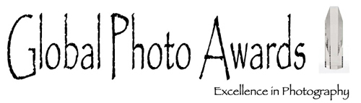

2010 Finalist and Gold Honorable Mention in The Worldwide Photography Gala Awards - The Dominant Colour Contest with the picture "Young Lady goes thru door".

2010 Finalist and Bronze honorable mention in The Worldwide Photography Gala Awards - Urban & country landscape contest with his “Hotel swimming pool”

2010 International Photography Awards.

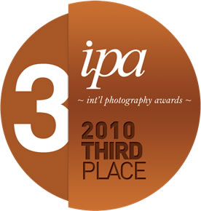

3rd place Advertising: Book Cover pro category with the cover for Italian novel by Lucia Tilde Ingrosso – “Io so tutto di lei".

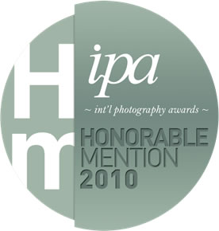

Honorable Mention in Fine Art - Nudes category for the winning entry "Private collection"

Honorable Mention in Fine Art - Still Life category for the winning entry "Light on tables"

Honorable Mention in People - Other category for the winning entry "People -

Honorable Mention in Nature - Flowers category for the winning entry "Poppies"

Honorable Mention in People - Lifestyle category for the winning entry "Winter surfer"

Honorable Mention in Travel / Tourism category for the winning entry "Man orders another beer"

Honorable Mention in Advertising - Annual Report category for the winning entry "GFMS Annual Platinum Survey 2010"

2010 Selection of the Hasselblad Masters in the category Beauty & fashion with a series of fine art analog erotica

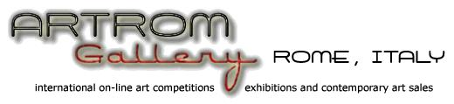

2010 - Fourth Place Award in the ARTROM Gallery, Rome, Italy’s TOPTEN Split Second Impulse International Photography Competition.

2010 - Telegraph.co.uk Daily Telegraph Photo competition: Sunshine was won by Edward Olive with his picture of poppies in Tuscany entitled “Composition in reds and browns” taken from his book of flower photography entitled “Seasons” edited by Citypulse in Santiago de Chile

2009 - one of ten finalists in the Wedding Social category of the Hasselblad Masters Competition. The Hasselblad Masters Award is the most prestigious awards in the industry.
2009 – First prize of the Jury of PHE PHotoEspaña in their competition "Otoño al aire libre"

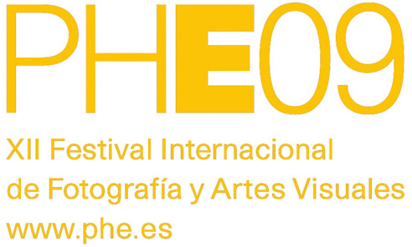

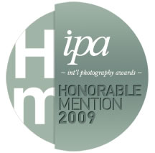

2009 - Honorable Mention in People - Wedding category for the winning entry "Real wedding photos."
2008 - First prize in the analog photography competition “Mi mejor positivado” de La Fotografía / Kodak Spain

Exhibitions
2012 The Darkroom Gallery, Vermont USA- The Human form
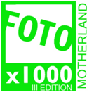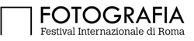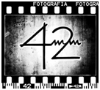

2011 Collective art photography exhibition Third edition of Fotox1000, the biggest collective photo exhibition in FotoGrafia 42, the International Festival of Photography of Rome 2011
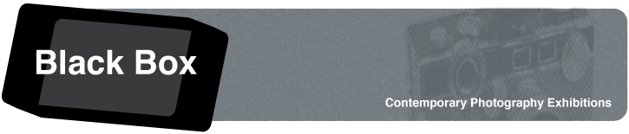
2011 Collective contemporary photography exhibition “Shut up and shoot” at the Black Box Gallery in Portland, Oregon USA.

2011 Kid Stuff collective exhibition of child portraits and photojournalism in the 1650 Gallery in Los Angeles California USA.

2010 - III EXPO ESREC "El agua despertando a la primavera" in the nature museum Valle del Alberche, el Barraco Ávila Spain – Collective exhibition – nature and landscape photography
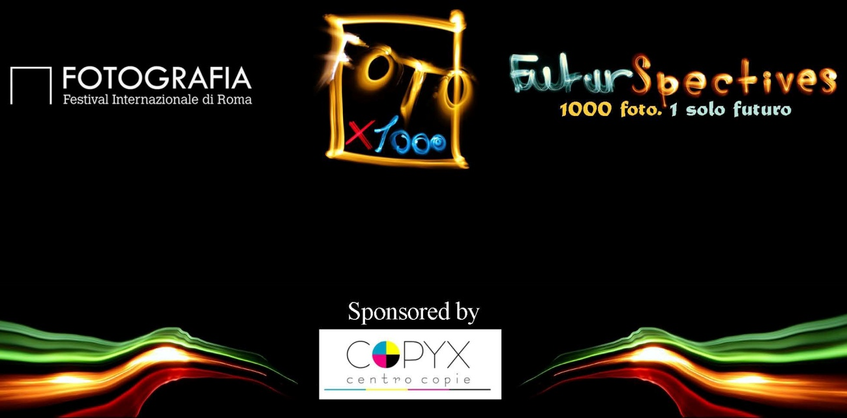

2010- FOTOX1000 II Futurspectives Rome Italy Collective exhibition – fine art photography



2010 - Citypulse por Chile Citypulse for Chile - Galería Moro - Santiago de Chile – Collective exhibition – fine art photography

2009 - Hasselblad Masters 2009 – Copenhagen, London, New York, Hong Kong,– Collective exhibition – wedding photography

2009 - Citypulse Stop making sense (lomography) - Galería Moro - Santiago de Chile – Collective exhibition – lomographic photography

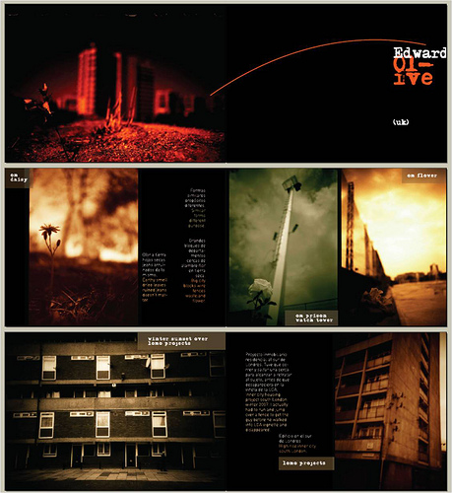

2009 - Citypulse Biosphere Biosfera - Galería Moro - Santiago de Chile – Collective exhibition – urban photography

2009 - Photoespaña PHE “El agua de Madrid” – Madrid - Collective exhibition – fine art photography

2008 - “Rioja en los Sexto Sentidos” – Bodegas Franco Españolas – La Rioja - Collective exhibition –social photography
blications by Edward Olive

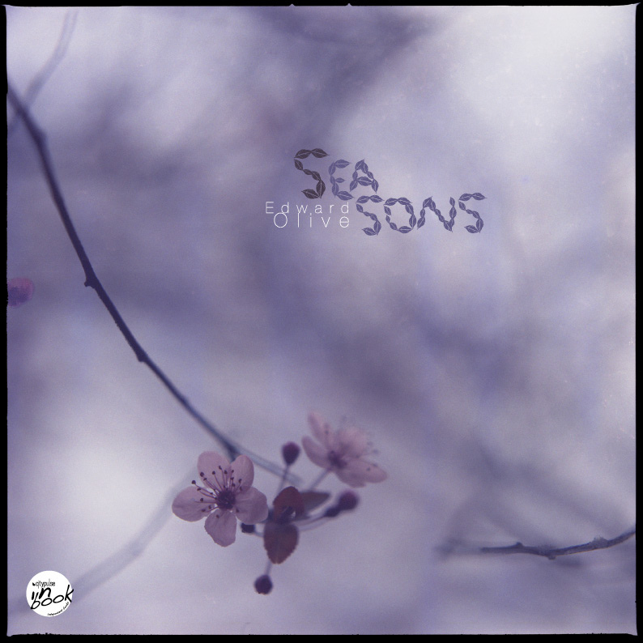

2010 “Seasons” (Published by Citypulse Chile) – a collection of fine art analog flora and fauna photography.

Seasons
By Edward Olive
Price:€26.30

http://www.lulu.com/product/paperback/seasons/13621908
Preview http://cargocollective.com/citypulse#784079/Seasons-new-book-by-Edward-Olive

Seasons evokes a photographic journey through the times of the year. From the first outbreaks and shades that bloom spring passing by the light and heat of the summer trough the cold darkness that strips the trees in fall and winter. The appetite for experimentation has led Edward Olive to achieve new dimensions in the artistic description of urban spaces, transforming a simple glimpse of nature in a work of art.

2009 – “Private collection”
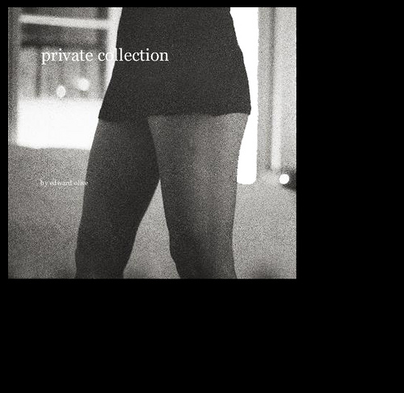
A private collection of the work of Edward Olive. Exclusively fine art female nudes and erotica, moments of intimacy in public and private, flashes of female sensuality taken in hotel rooms at night, private residences, public parks, beaches, lifts or wherever. Shot mainly on medium format film - color, black and white, negative & slide using the Hasselblad 500cm and Carl Zeiss t* lenses. Also used: 35mm compact and reflex cameras and the panoramic Hasselblad xpan. Shot exclusively using available light, without the use flashes or studio lighting. Available for online purchase from http://www.blurb.com/bookstore/detail/1096026
Book & CD covers
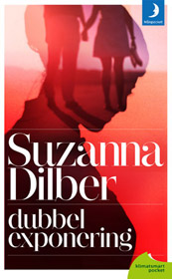

2012 - cover of the novel by Swedish author Suzanna Dilber – "Dubbelexponering"

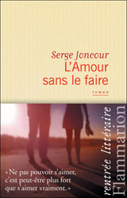
2012 - cover of the novel by French author Serge Joncour – "L'amour sans le faire"
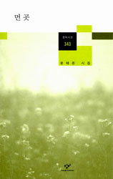
2012 cover of South Korean book of poetry
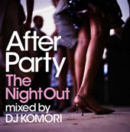
2012 cover of CD After Party The Night Out mixed by DJ Komori
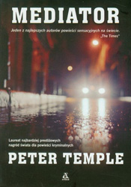
2011 - cover of the crime thriller Mediator by Australian novelist Peter Temple - "Mediator".
In 2007 Peter Temple won The Golden Dagger, the world's biggest crime writing prize. Previous winners have included Patricia Cornwell, Ian Rankin, Ruth Rendell & John le Carre.
www.papirus.boleslawiec.pl/ksiazka/Temple-Peter/Mediator
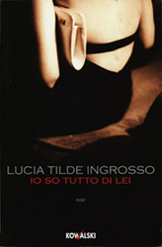
2009 - cover of the novel in Italian by Lucia Tilde Ingrosso “Io so tutto di lei”
www.lafeltrinelli.it
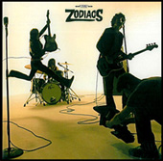
2006-11 Various record and CD covers for Dro Atlantic Records and other record companies
Publications featuring Edward Olive's pictures

2012 Paragraph Me - ipad & tablet magazine of short stories

2012 El Mundo Magazine Spanish national newspaper's Sunday magazine supplement

2012 The photography book "El desnudo artístico en blanco y negro" (The artistic nude in black & white) published by Artual Ediciones

2012 HESO Magazine - photography & cinema review
2012 Life is a Bed of Roses - The 2010 project with Macmillan Cancer Support - foreword by Tony Benn

2009-2011 CFYE Photography and street art magazine

2011 DOF - photography magazine

2011 Anormalmag - photography & visual arts magazine from Chile

2011 IPA Lucie Foundation Annual book
A collection of fine art photography by various international artists published by International Photography Awards

2011 Hyde Park Photography Magazine - the magazine made by photographers for the photography addicted whose mission is to provide an international showcase for photographers from around the world.
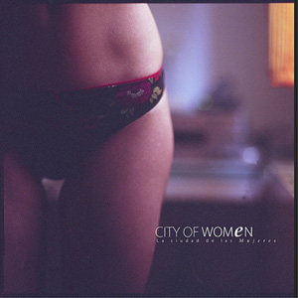
2011 Citypulse Fine art photography book City of women
Featuring work by photographers Andrew Knowles / Anna Morosini / Bogna Altman / Christer Johansen / Edmund Leveckis / Edward Olive / Erika Pham / Isabelle Marcelli / Jon Jacobsen / Michaela Knizova / Monika Drzazgowska / Ontoshiki / Patricio Suarez / Sasha Nikitin / Sebastián Utreras / Tommy Oshima / Viola Cang

2011 UNLIMITED GRAIN / PORTRAITS/ from THIAPS, The International Analogue Photographic Society, fine art portrait photography book
2011 Year-Book UNLIMITED GRAIN 2011 by THIAPS also known as "Film is not dead it just smells funny"


2011 Snapixel magazine


2011 Le Negatif Mag
2010 “Urban & country landscape” – a collection of fine art photography by various international artists published by The Worldwide Photography Gala Awards

2010 IPA Lucie FpindationAnnual book
A collection of fine art photography by various international artists published by International Photography Awards


2010 – Strongbox magazine - photography, art, graffiti culture, music, film quarterly US review
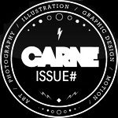
2010 - Carne Visual Arts Magazine

2010 Aire Libre – Spanish travel magazine
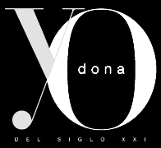
2010 El Mundo Yo Dona magazine

2010 Outside magazine
2010 - The book “Everyman’s Marx” by Roger Gatham & Jake Davis

2010-2010 – Citypulse fine art photography magazines

2009 – Oui magazine – French bridal magazine
2009 - La Fotografía Digital y Actual – Spanish photography magazine – 5 page feature – fine art erotica
2008 – La Fotografía Social – Spanish photography magazine – 5 page feature – wedding photography
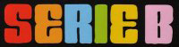
2006-7 – various Spanish music, rap, hiphop & urban culture magazines including Serie B, Hip Hop Nation & Hipflow.

2006-7 – Spanish sports magazine Urban Fit

2007 - Gear Patrol gentlemen's magazine
Television programs featuring Edward Olive's pictures

20010-2008 Explorers Spanish TV travel program (Canal Nou & Punt 2)
Corporate clients

Edward Olive’s corporate clients include:



Getty Images / Flash Press Media / Fotobank Russia



RTVV / Canal Nou



Warner Music/ Dro-Atlantic



Plan Creatif Corporate

Zehnder Communications



ACP Magazines Limited



Whalen, Hennig & Merritt



Wydawnictwo Amber Sp. z o.o.

A Sadowski

Maarten Muntinga-Rainbow Pocketboeken



Thomson Reuters / GFMS



Champagne Paul Clouet



Kowalski Editore



Kings College Schools

Black & Gold France

Chili Solutions

99Grad Grafikdesign GbR



Random House Mondadori, S.A.



Snob.ru



Tuber Productions Pte Ltd

Dimensin Marketing Directo, S



BBDO Dsseldorf
GmbH



Marko Agentur Brandt Gbr

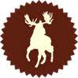

Moosylvania

Ansible

J. Walter Thompson GmbH



bplusd marketing & sales GmbH


Prisa / Grupo Santillana/ Santillana Ediciones Generales

Microfusa

Changbi publishers Inc South Korean book publishers

Contrapunto Communication agency in Madrid & Barcelona

Selfridges & Co department store

Artual Ediciones SL Photography book & magazine publishers

Wunderman S.L. - Direct advertising agency

Mnpocket - Book publishers


Viajes Iberia - Travel agency



Flammarion French book publishers



Manpocket - Swedish book publishers



Bonnier Pocket - Swedish book publishers



Sanoma Media - European media & learning group
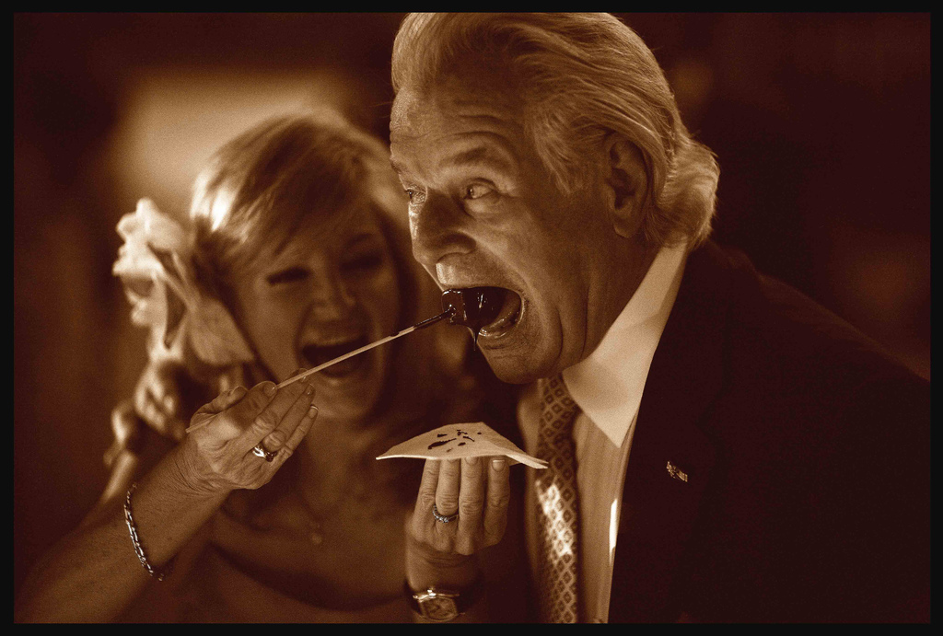
Equipment used:
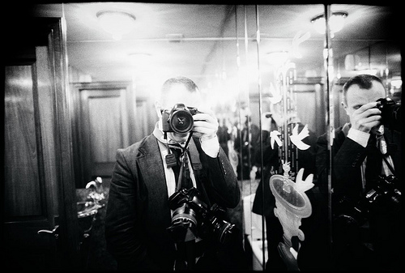
Digital:
canon eos 5d mkii
canon eos 5d
35mm auto focus:
canon eos 1,
5 x eos 5 / ae2,
eos 300 / rebel
digital & 35mm auto focus lenses:
canon ef 85mm L f1.2 USM,
canon ef 50mm L f1.2 USM
canon ef 24mm L 1,4 USM ,
canon ef 14mm L 2.8 USM,
canon ef 70-200mm L f2.8 IS USM,
canon ef 180mm L f3.5 macro,
canon ef 24mm L tilt shift
canon ef 50mm 1.4 USM,
canon ef 50mm f2,5 compact macro,
canon ef 15mm f2,8 fisheye

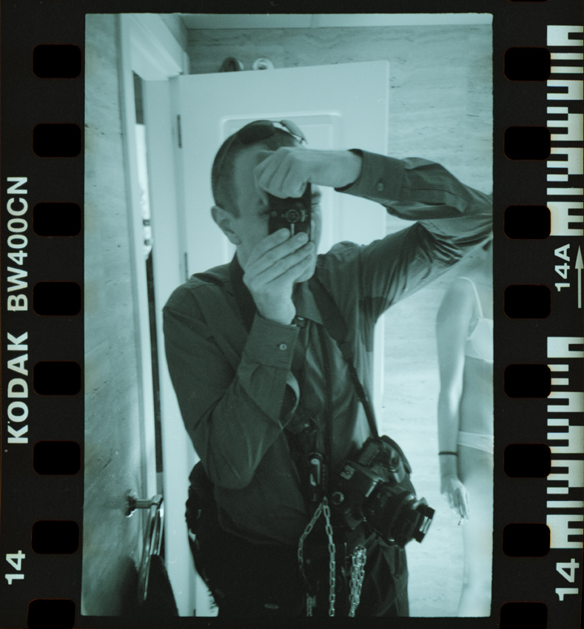

Medium format
2 x Hasselblad 500 c/m + Carl Zeiss planar 80mm f2.8 t*, Carl Zeiss Biometar 50mm f4 t*, Carl Zeiss Sonar 120mm f4 t* Carl Zeiss 150mm t* f4 Carl Zeiss 250mm f5.6 t*+ a12/a24/a16/a16s
3x Mamiya m645 1000s+ Sekor 80mm f1.9 + Sekor 50mm f2.8
Rolleiflex + carl zeiss f3.5 biometar
2x Pentacon six TL + Carl Zeiss 80mm f2.8, 50mm f4, 150mm f4
Other medium format cameras
Afa Isolette
Agfa Clack
lomo Lubitel universal
Pouva start
Holga cfn
Holga Woca gcfn
Certo certina
Certo phott
Halina 6-4 achromat
Brownie cresta
Diana camera (original) x2
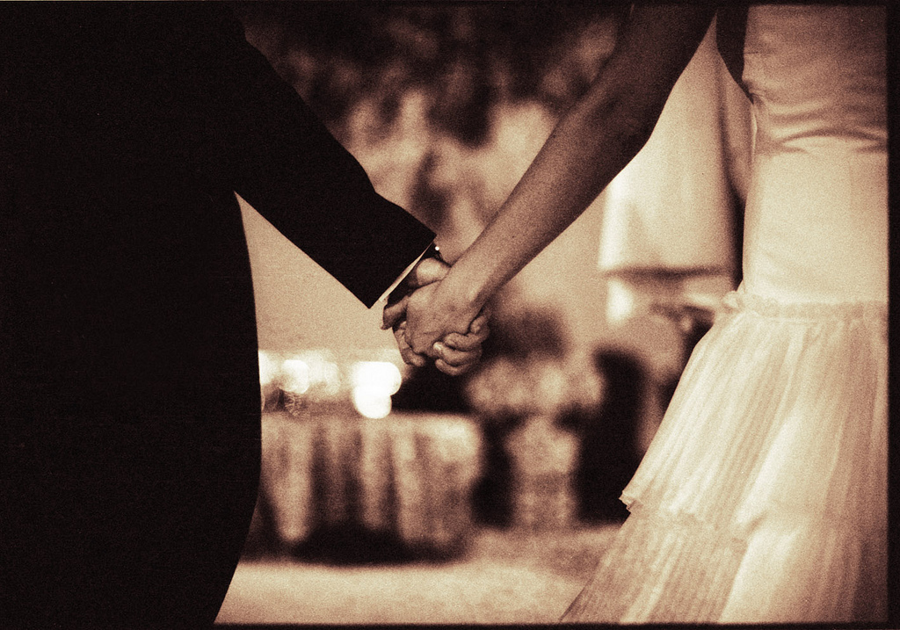
35mm manual focus cameras
3x Asahi Pentax Spotmatic II + full range of Super Takumar lenses
2x Olympus om2, om40 + fast om lenses
3x Minolta srt 202/203 + fast lenses
35mm zone focus cameras
Lomo Smena symbol
Lomo Smena 8m
Lomo Smena 8
35mm rangefinder cameras
Kiev ttl
35mm auto focus compact/ point and shoot cameras/ 35mm zone focus compact
Leica cm (fixed focus 40mm f2.8)
Leica mini ii (fixed focus 35mm f3.5)
Contax t2
Contax tvs ii
Olympus mju ii /stylus epic (fixed focus 35mm f2.8)
Fujifilm natura black (24mm f1.9)
Canon af 35 ml (40mm f1.9)
Lomo lca (original)
2x Olympus xa-2
Olympus xa-4
Minox gt
Olympus pen (35mm f2.8 lens half frame zone focus)
Vivitar ultra wide & slim
Darkroom
Kaiser VCP 6005 color and black & white enlarger
Schneider-Kreuznach APO Componon 50mm f2.8 multi-coated
Rodenstock APO Rodagon HM multi-coated 45mm
Rodenstock Rodagon WA 40mm
Rodenstock APO Rodagon N 80mm
Rodenstock Rodagon WA 60mm
Rodenstock Rodagon 105mm f5.6
LPL 40x50cm 16x20in easel
Vacuum easel 50x70cm 20x28in
Magnetic borderless easel 40x50cm 16x20in
Four blade 30x40cm 12x16in easel
Multi-mask multi-format multi-print easels
Silverprint cotton fiber archival print washer 50x60cm 20x24in
Nova 30x40 12x16in Fiber based print slot processor for black& white prints
Nova Club 30x40 12x16in four slot print processor for color prints
Paterson system 4 film developing tanks
Nova temperature 3 pot dip & dunk controlled C41 color negative E6 slide transparency 35mm, 120 and 220 film format processor
Zone VI print drying screens
Fiber based paper press
Studio

Continuous pro CFL studio lighting

LED pro portable studio lighting

Tungsten pro lighting

Multiple head Bowens Gemini pro strobe flash with portability location battery paks, radio triggers

Multiple Canon speedlights

Octobox, softboxes, snoots, reflectors, honeycomb grids, barndoors, beauty dish.

Portable studio backdrops, reflectors, flags, diffusers for portrait, group and fashion.

Mini studio for still life, jewelry and product.
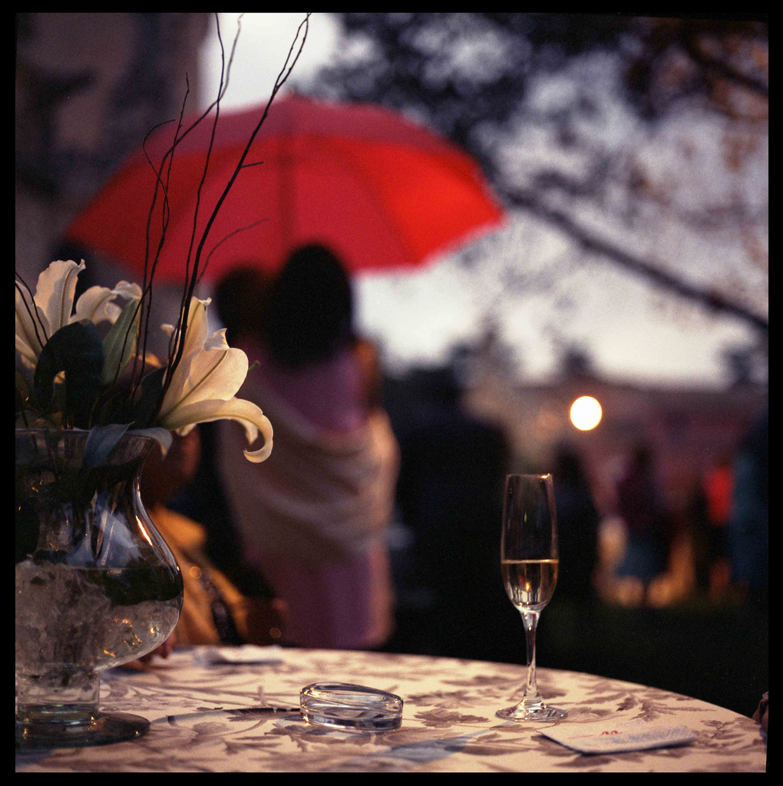

Bio

Edward Olive is a Fine Art, wedding & portrait photographer based out of Madrid, Spain.
Edward Olive was a commercial litigation lawyer in London & Paris until throwing in the towel to pursue his more artistic interests. Edward got into photography by chance only in 2005 when he purchased his first camera, an entry level digital reflex Canon 350d to shoot his own actor’s book on a tripod with remote control. Finding he enjoyed the experience he started shooting actor and musician friends and the people living and working in his neighborhood Chueca (Central Madrid’s equivalent of Soho or Le Marais).
Dissatisfied with the focused perfection of modern digital images and seeking an alternative look for his pictures he started adapting analog lenses (he extracted from broken old cameras with a large metal hammer we understand) onto his digital reflex using masking tape and built DIY lighting from microphone stands, disco lights and Kelvin correction gelatin discarded by technicians on his acting jobs.
In autumn 2006 he bought his first film camera, a 1980’s Russian point-and-shoot (a cult Lomo LCA) using some very expired color film they were throwing out of the local photography store. Delighted with the dreamlike qualities and vintage colors, he hasn’t looked back. He continues to shoot almost exclusively analog cameras, still preferring the oldest expired film he can find, shunning the contemporary digital post-produced Photoshop look of current commercial and fashion photography, in favor of the grittier, earthier, unpredictability of expired film whether color negative, slides, black & white or Polaroid type instant film. Edward freely admits that it wasn’t until he bought his first Hasselblad in 2007 (the classic V series 500c/m with Carl Zeiss lenses) that he really found his instrument of choice. He still uses other cameras for reasons of variety, speed, ultra fast lenses or the discretion and convenience of a 35mm compact camera but takes a pair of V series Hasselblad 6×6 cameras, Mamiya M645 1000s and wheelie bag loaded with 120 & 220 film backs and inserts, as he says, when he really means business.
Edward’s pictures range from street photography to nudes, often combining his location wedding travel to shoot personal projects inspired by the new places and people, admitting he still takes more photos for himself just for fun than he does to try and sell later to clients, taking some consolation from the new ideas that come from expression, reinvention and experimentation, free from any commercial pressures, that can later be applied at work to put food on the table. Edward aims to project in his work the contrasts and contradictions that exist within him and within people in general. He wears Italian silk suits to work but takes some shots that step out of line. He uses perhaps the world’s best cameras and lenses yet feeds at times them with the worst Chinese made “black & white” film that has in reality neither black nor white dreamy red blurred images. A combination of the perfect public image and internal private thoughts that combine to make up the people we are, conforming and breaking society’s norms. His aim is to one day attain the vocal control of Pavarotti yet to turn it on its head “Sex Pistols style” refusing to sing correct notes.
Ironically Edward has said from his earliest years he never wanted to get married himself, even admitting that just seeing the grooms standing at the front of the cathedrals with everyone looking gave him a cold sweat until photographic matters got him back to thinking shutter speeds on the little kids running around at the back of the congregation and the inadvertent rising up of female guests’ dresses. Recently there has been a slight softening of his hard line, stating that if he ever did get hitched it would be as Elvis in Las Vegas with the bride as Marilyn on YouTube with only one photo taken, preferably of the bride and preferably without all her clothes, which would be the role of the only guest.
Artistically Edward lists influences that include Patrick Demarchelier, Jean Loup Sieff, Guy Bourdin, Jane Bown, Nigel Parry, Norman Parkinson, Cecil Beaton, John Deakin, David Bailey, Brian Duffy, Terence Donovan, Terry O’Neill…. However he feels that more important than seeking same medium influences are other sources of inspiration whether other artistic media such as music, literature, dance o quite simply the world you live in.

New for 2013

- Analog will be available in handmade darkroom enlargements produced personally and manually by the photographer in sizes 20.3 x 25.4cm (8 x 10in) 24 x 30.5cm (9½ x 12in) 30.5 x 40.6cm (12 x 16in) 40.6 x 50.8cm (16 x 20in) 50.8 x 61cm (20 x 24in) limited to 5-10 enlargements per negative (depending on picture), signed and numbered personally by the photographer using Sakura archival quality pen accompanied by signed and dated certificate of authenticity which may include technical note.
- Pictures produced from analog film negatives will not be delivered in high resolution scan files and but in authentic handmade darkroom enlargements produced personally and manually by the photographer in his own darkroom developing by hand 35mm and medium format film in various film developers employing a system of Paterson development tanks and using a professional 35mm and medium format enlarger producing images on professional and fine art photographic papers purchased, or produced by the photographer using hand painted emulsions. The image production laboratory system is based on the use of up to 5 chemical trays or Nova darkroom fiber based print processor on special fiber based paper frames and professional German-made enlarger Kaiser 6005 fited with the finest high level professional German-made enlarging lenses available including Schneider-Kreuznach APO Componon 50mm f2.8 multi-coated and Rodenstock APO Rodagon HM multi-coated 45mm for 35mm film and Rodenstock Rodagon WA 60mm and Rodenstock APO Rodagon N 80mm for 645 and 6x6 images and Rodenstock Rodagon 105mm f5.6 for 6x7 and 6x9. A hand made professional archival museum standard fine art fiber based paper grade print washer imported especially from England is used with washing periods of up to 1 ½ hours per print. Prints are individually, manually and personally judged and calibrated by the photographer using a system of test strip prints, contrast filters, graduated or multi-grade paper and may include original physical darkroom techniques such as cyanotype, lith prints, tinting and toning, textures, layered negatives, pushing and pulling, double exposures etc. according to the necessities and possibilities of each negative. Papers may include Ilford MULTIGRADE IV FB Fiber 255g/m², BERGGER Prestige "CB" VC FB, BERGGER Prestige "CM" VC FB, Bergger Prestige Fine Art Portrait, Oriental New Seagull Select VC-FB WARMTONE, Rollei Vintage 128, ADOX MCC110 FB VC (Gloss), Fomatone MG Classic 132, Fomatone MG Classic 532 II NATURE, Fomatone MG Classic 132, Fomatone MG Classic Chamois 542 II, Fomatone MG 332 MATE WARMTONE, Fomabrom Variant 112 (matte), Kentmere FINEPRINT VC FB (Gloss), Varycon VC FB, Ilford MULTIGRADE IV RC, ILFORD MULTIGRADE IV RC Portfolio and RC Gallery papers, cooltone o warmtone, FB 100% natural cotton fiber, MG double weight fine art papers.
- For VIP clients who wish to contract the production of a series of art gallery level prints in a limited number of pictures, these can be produced at a price per picture which may vary according to the number contracted. Genuine fine art analog pictures are generally produced for VIP clients and the photographer may use a number of his classic cameras including Hasselblad V series and Mamiya 645 in formats 645 6x6 and 4.5x4.5 y Mamiya 645 and “35mm medium format” Hasselblad Xpan Panoramic pictures. It is to be stressed that analog photos are of a high artistic content and can include film grain, paper textures, sloppy borders, film edge, chassis edge, brush strokes from application of emulsion by hand, signs of washing and drying by hand and other elements related to their hand-made nature. These pictures have been finished to archival quality but should be stored in a sensible and appropriate manner which will include not placing them in direct sunlight, excesses of temperature or humidity and that any mounting or framing materials that come into direct contact with the photo should be acid-free. The fine art fiber based prints have received archival standard washing, natural air drying on professional fiber drying screens and pressing in a press between acid-free blotting paper during minimum 24 hours but sensible measures should be taken to maintain the flatness of the photo including not rolling it too tight in transportation tubes and mounting it professionally in a way that helps to maintain flatness.
- Digital cameras with full frame sensors, high ISO capabilities and super-fast f1.2 lenses allow the photographer to obtain photos without the use of lighting, flashes or strobes and thus the capture of natural real looking shots. In the case of analog photography low ISO films may be used and fairly slow lenses particularly in the case of medium format wide angle or tele lenses. The photographer may compensate for this by the use of between 1 and 8 separate sources of continuous light, CFL or tungsten or flash heads or strobes fired simultaneously by radios. This has its advantages and disadvantages. The photographer will take what he considers in his opinion to be the best artistic and photojournalistic decisions.
- If analog color pictures are produced during the photography session they may be produced by hand by the photographer using C41 processing for color negatives and Xpro cross processed slde transparencies or E6 technology for slide film available in hand made prints produced by the photographer on Kodak Supra Endura or Fuji Crystal Archive paper using Tetanol and Kodak RA-4 chemistry

http://www.edwardolive.info/

© All texts and photos copyright Edward Olive

